ABBY STARMER ART
Visual Portfolio — Products & Services
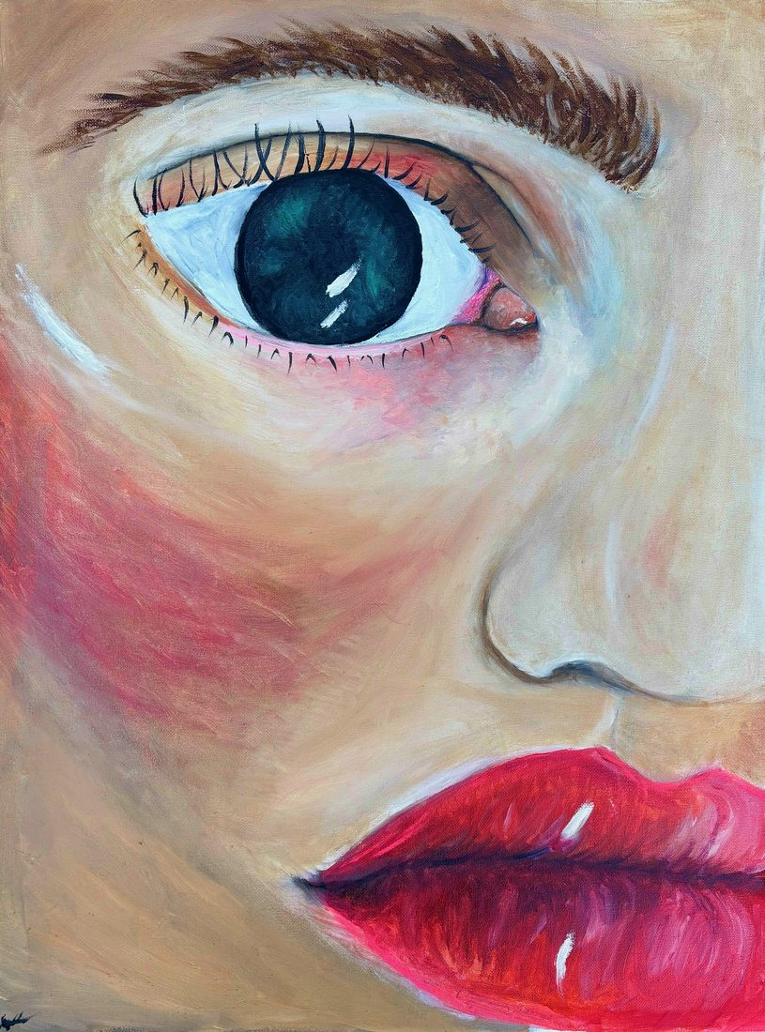
Soft Spoken
Oil on canvas · 18" × 24"
Forbidden Kingdom Festival — Vendor Application
Abby Starmer · abbystarmerart@gmail.com · abbystarmerart.org

Original Oil Paintings — Available
One-of-a-kind, hand-painted in oil on canvas. Each piece is signed and ready to ship.
  Soft Spoken  Oil on canvas · 18" × 24"  Original For Sale — $800 | 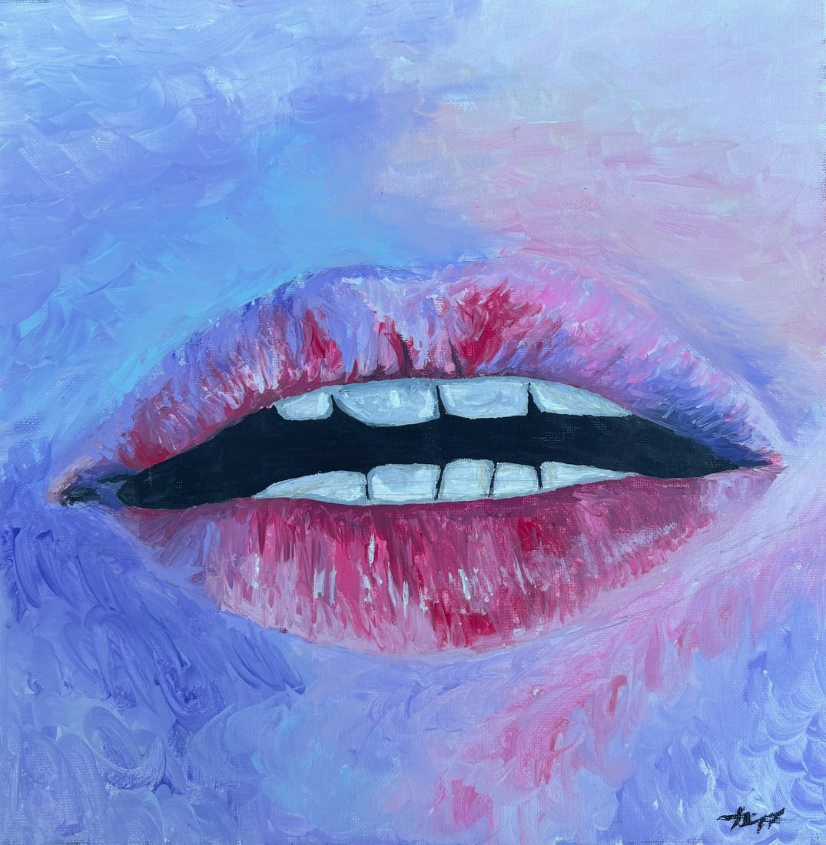  Whisper  Oil on canvas · 12" × 12"  Original For Sale — $500
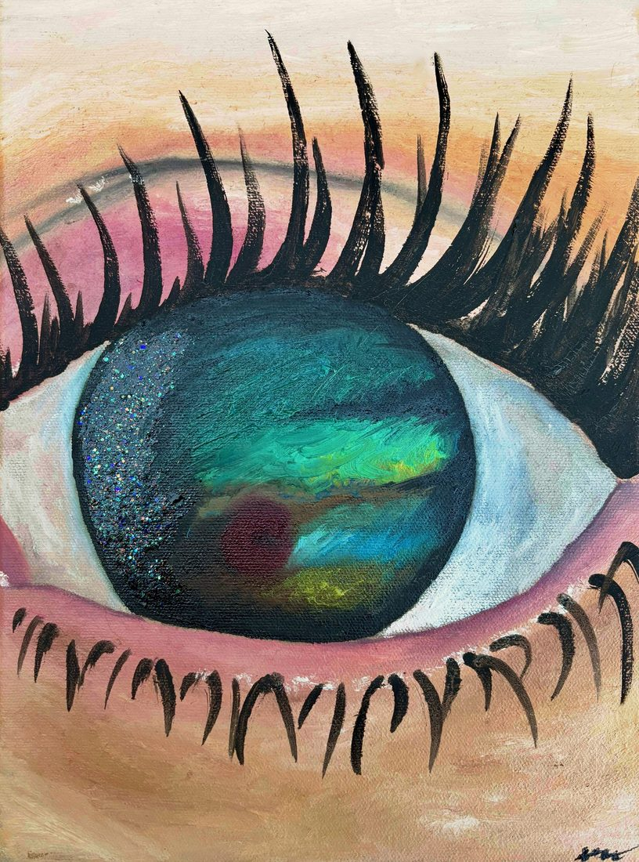  Iridescent  Oil on canvas · 9" × 12"  Original For Sale — $400 | 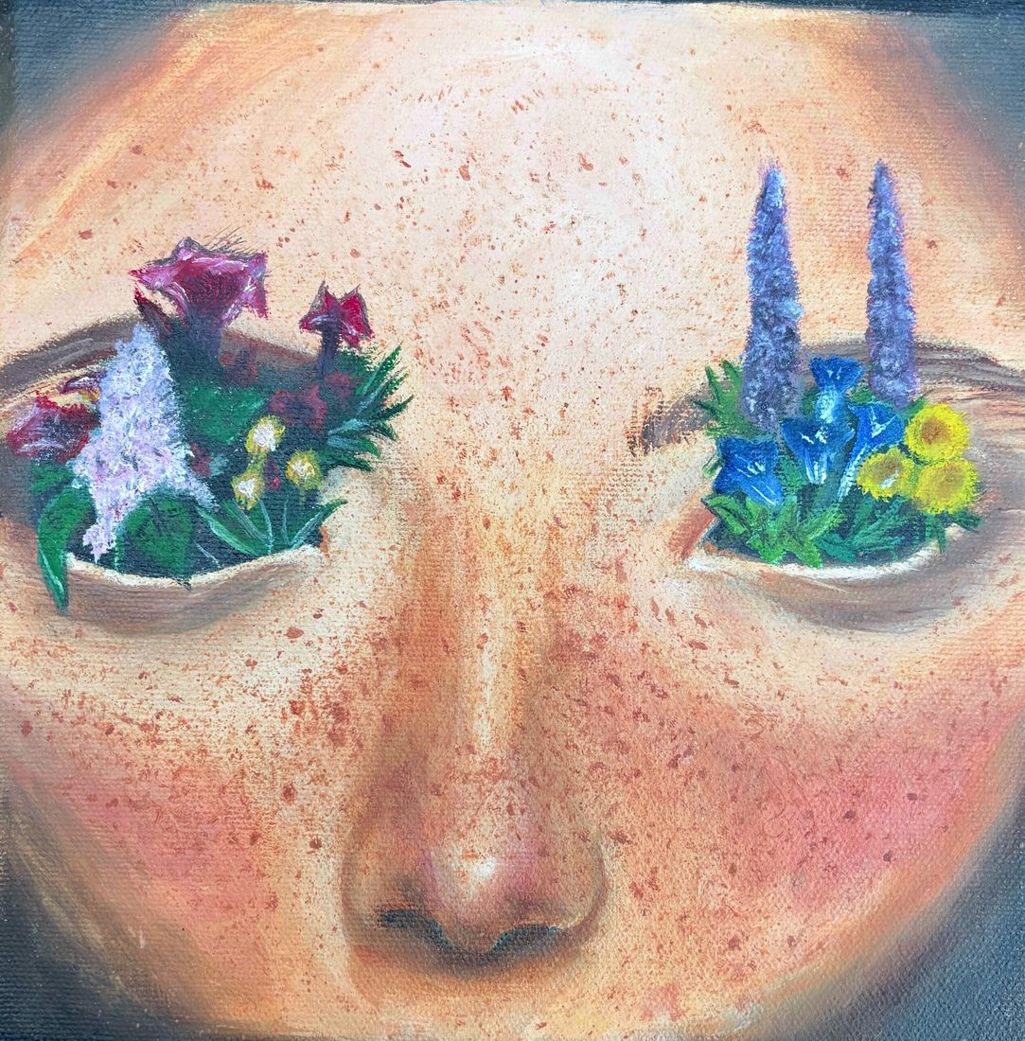  In Bloom  Oil on canvas · 8" × 10"  Original For Sale — $275
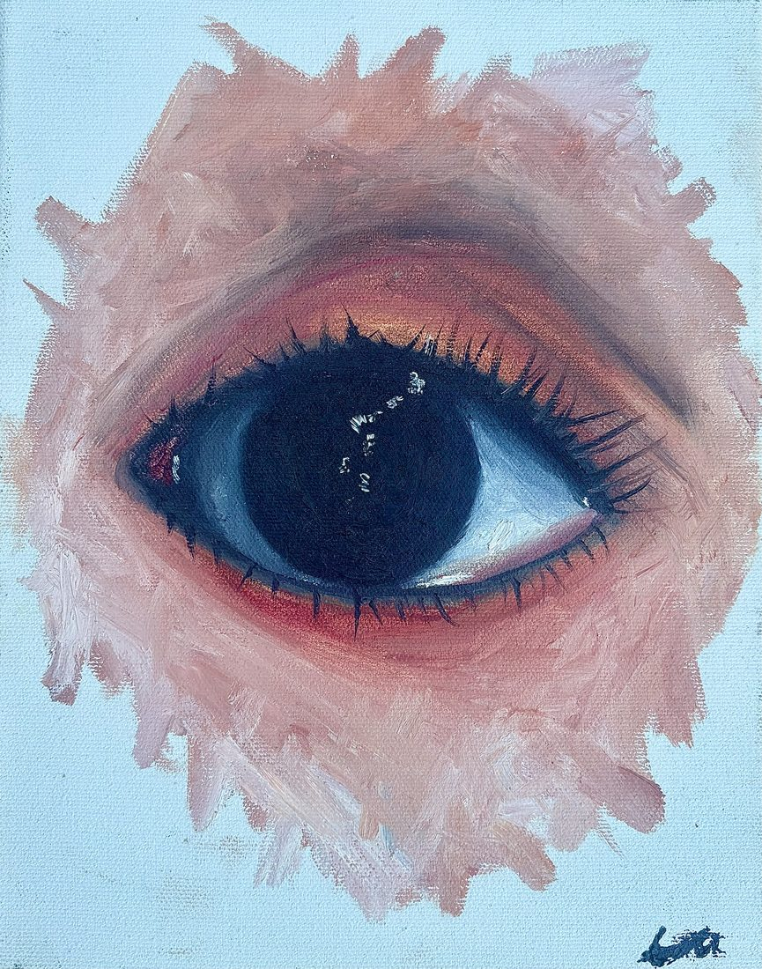  Coral Hour  Oil on canvas · 8" × 10"  Original For Sale — $275 | 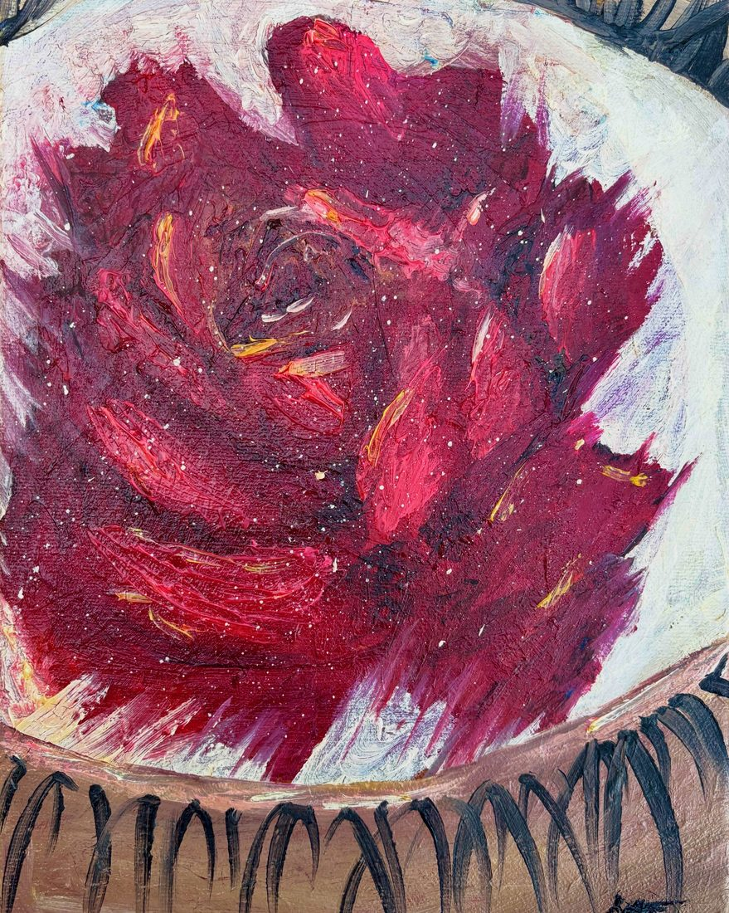  Inner Fire  Oil on canvas · 8" × 10"  Original For Sale — $275

Catalog Pieces — Available as Prints & Stickers
Originals are sold, but each of these pieces is still available as a fine art paper print, gallery-wrapped canvas print, and vinyl sticker.
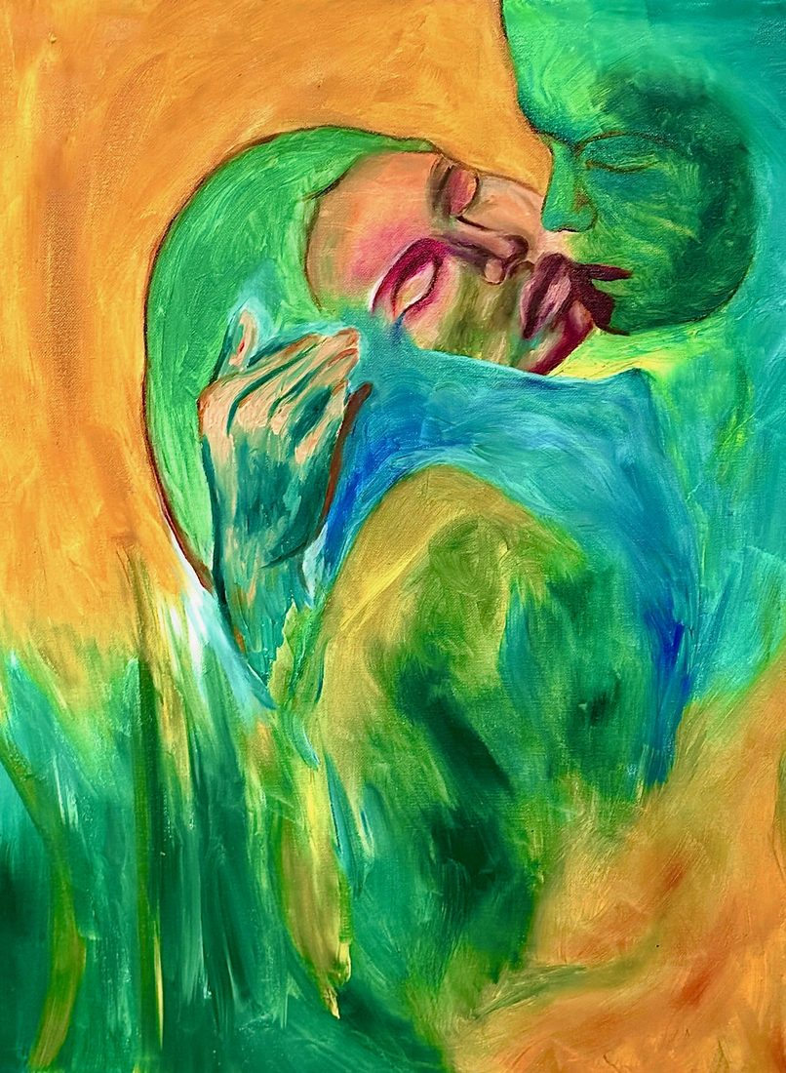  Pulse of Green  Oil on canvas  Sold — available as print/sticker | 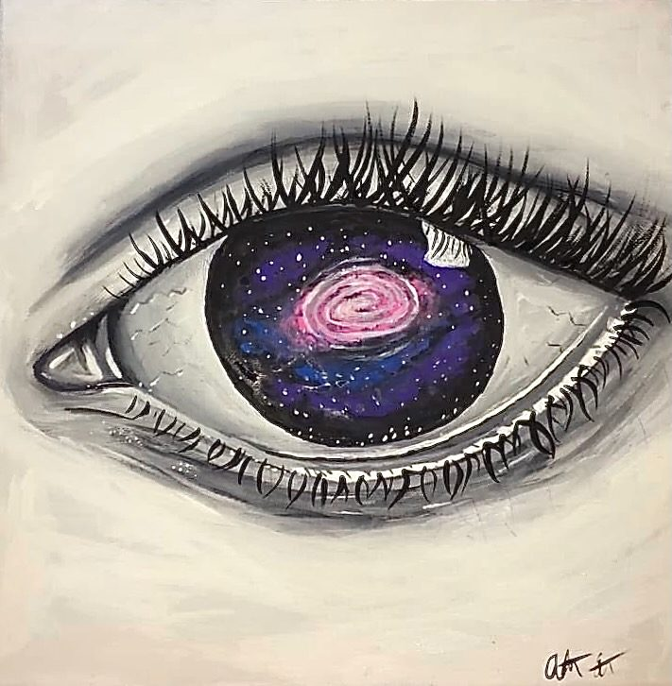  Cosmos  Oil on canvas  Sold — available as print/sticker
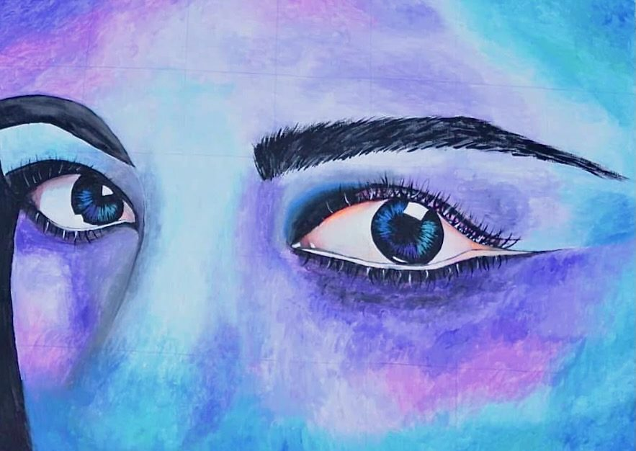  Twilight  Oil on canvas  Sold — available as print/sticker | 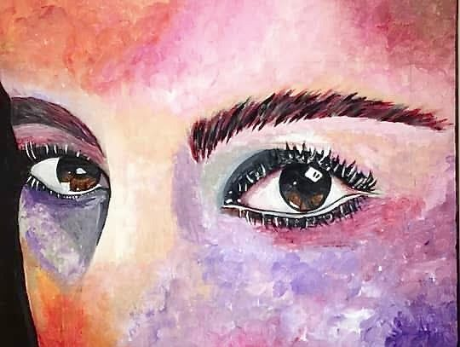  Golden Hour  Oil on canvas  Sold — available as print/sticker

Prints — Paper & Canvas
Every painting in the catalog is available in three sizes on either heavyweight matte fine art paper ($28 – $75) or gallery-wrapped canvas ($85 – $185). Below: an example reproduction shown at print size.

Iridescent — example print reproduction
Paper from $28 · Canvas from $85

Weatherproof Vinyl Stickers
Die-cut weatherproof vinyl stickers of every painting in the catalog — flat $8. Strongest impulse-buy item in the booth. Sized to the natural shape of each piece (square, portrait, or landscape).

Example: In Bloom vinyl sticker
Approx. 2"–3" sticker · $8 each

Live Painting Activation
Easel set up at the booth across the weekend. Attendees can sit briefly, watch the process, and the finished piece becomes part of the festival's art collection, a raffle, or an auction — per the festival's preference. The same body of work shown throughout this document is representative of what is produced live on-site.
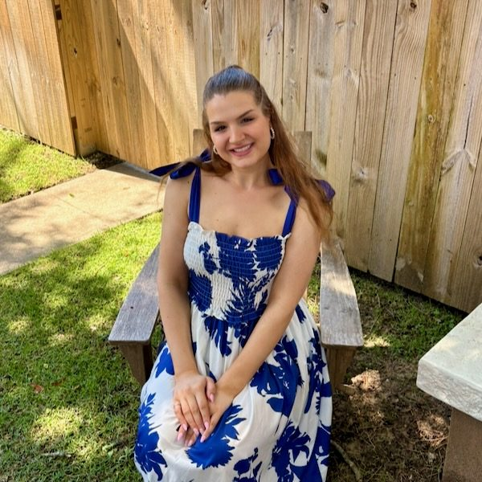
Abby Starmer — artist
Nashville-based oil painter · @abbystarmerart
Full catalog and current pricing:
abbystarmerart.org
abbystarmerart@gmail.com · Instagram @abbystarmerart

